Instant Recovery Point & Large disk support
Instant RP feature is combined with multiple individual features -
- Ability to see snapshot taken as part of backup job to be available for recovery without waiting for data transfer to complete.
ETA: Available now.
Please note that this will reduce the wait on snapshot to be copied to vault before triggering restore. Also, this will eliminate the additional storage requirement we have for backing up premium VMs.
If VM has all disks into one storage account and customer selects same storage account as part of restore, restores would be fast. Other configurations, restore would remain same.

- As part of above feature, we will also enable some data integrity checks. This will take some additional time as part of backup. We will be relaxing these checks as we move and so it will reduce backup times.
ETA: October end.

- Support for 4TB unmanaged disks
ETA: October end.

- Ability to use original storage accounts (even when VM has disks are distributed across storage accounts). This will make restores faster for a wide variety of VM configurations.
ETA: October end.
Please note this is not same as overriding the original VM.

- Ability to do above things for managed disks.
ETA: December.

What is Changing?
Today backup job consists of two phases:
- Taking VM snapshot.
- Transferring Vm snapshot to Azure Backup vault.

A recovery point is considered created only after 1 and 2 are done. As part of Instant RP, we will create recovery point as soon as snapshot is completed. You can also restore from this recovery point using the same restore flow. You can identify this recovery point in portal using “snapshot” as recovery point type. Once the snapshot is transferred to vault, recovery point type changes to “Snapshot and Vault”.
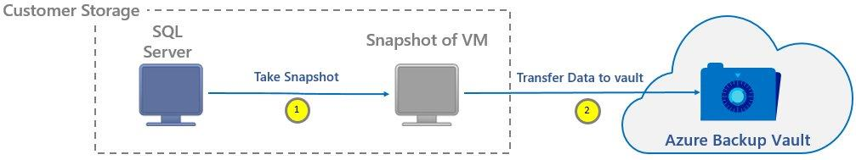
By default, we will retain snapshots for 7 days. This allow to complete restore faster from these snapshots by reducing the time required to copy data back from vault to customer storage account.

What are the some must-knows?
- This preview feature once enabled, can’t be reverted. So, all your feature future backups will go into this flow.
- This is currently not supported for Managed Disks. We are working to get managed disks support. If you are planning to migrate to managed disks in next 3 months, please DO NOT join this private preview. If you have VMs on managed disks as part of subscription, that is OK as those VMs will go through normal backup flow. Only migration of VMs between unmanaged and managed is not supported.
- Since we store snapshots to boost recovery point creation and also to speed up restore, you will see storage costs corresponding to snapshots for the period 7 days(currently snapshots will be kept for 7 days – this is fixed and we have plans to make this a choice in coming releases).
- If you are doing a restore from Snapshot recovery point for a Premium VM, you will see a temporary storage location being used while we create the VM as part of restore.

How do I get this feature?
Please execute following cmdlets from an elevated PowerShell terminal:
- Login to Azure Account.
PS C:> Login-AzureRmAccount
- Select the subscription which you want to register for preview
PS C:> Get-AzureRmSubscription –SubscriptionName "Subscription Name" | Select-AzureRmSubscription
- Register this subscription for private preview
PS C:> Register-AzureRmProviderFeature -FeatureName “InstantBackupandRecovery” –ProviderNamespace Microsoft.RecoveryServices

Contact us:
Reach out to us: instantrpvteam@service.microsoft.com

