Hybrid migrations – On-premises migration admin account creation guidelines

To perform hybrid migrations from Exchange Server to Exchange Online, the on-premises migration admin account requires the following permissions in the source Exchange organization.

Source Exchange 2007, 2010, 2013, and 2016 Servers
Note: The migration account must have Exchange recipient management permissions.
For more information, see Assign permissions to migrate mailboxes to Exchange Online.

Assign Exchange recipient management permissions for Exchange 2007, 2010, 2013, and 2016 Servers
- Open Active Directory Users and Computers.
- Right-click on the migration account you want to give permissions to and then select Properties.
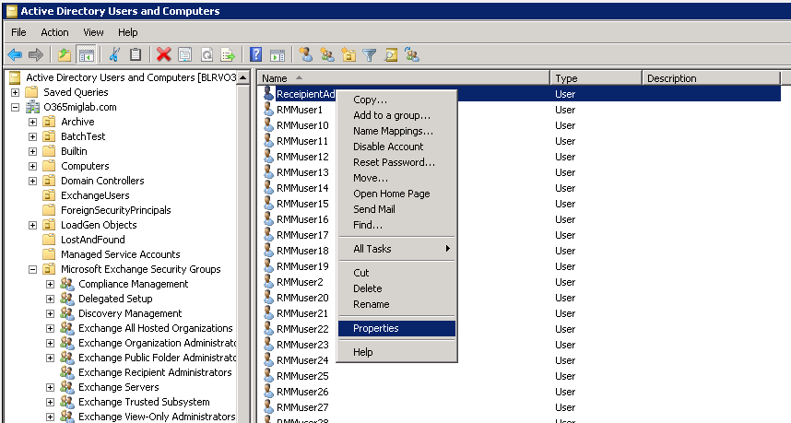

- In the migration account’s Properties window, select the Member Of tab.
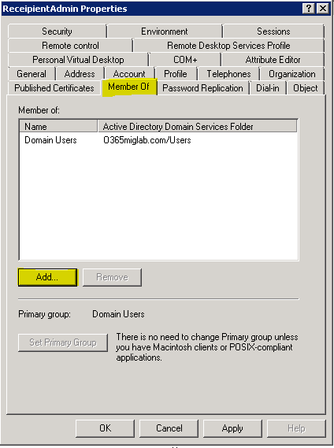

- Select Add.
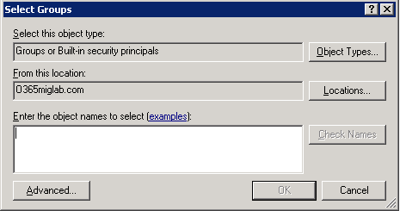

- In the Select Groups dialog box, in the Enter the object names to select box, type Recipient Management, and then select Check Names.
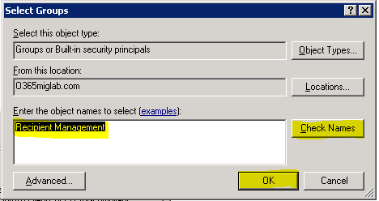

- Select OK. Recipient Management is now added. Select Apply and then OK.
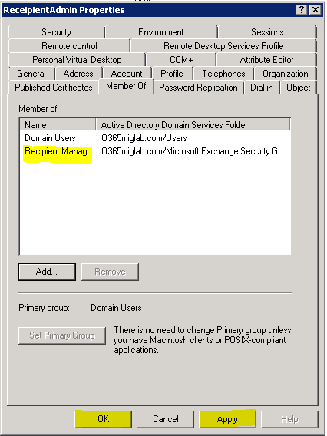

Source Exchange 2003 Servers
Note: The migration account must have Exchange full admin permissions.
For more information, see Overview of Exchange administrative role permissions in Exchange 2003.

Assign Exchange full admin permissions for Exchange 2003 Servers
- Select Start >Programs > Microsoft Exchange > System Manager.
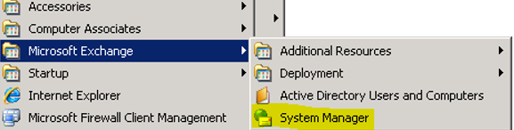
- Right-click the organization or the administrative group where you want to delegate administrative permissions, and then select Delegate control. The Exchange Administration Delegation Wizard starts.
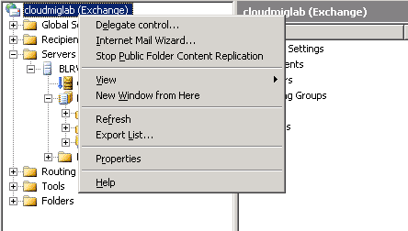
- Select Next.
- On the Users or Groups page, select Add.
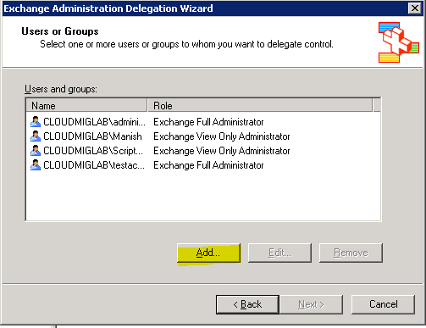
- In the Delegate Control dialog box, select Browse.
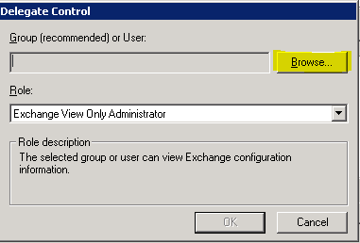
- In the Select Users, Computers, or Groups dialog box, select Object Types.
- In the Look in box, select the name of the user or the group that you want to add, and then select OK.
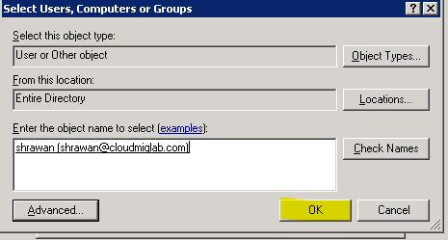
Note When you select the appropriate location in the Look in box, you can view the list of users and of groups from Active Directory or you can view only a list for a particular domain.
- In the Role drop-down list box in the Delegate Control dialog box, select one of the following types of administrative permissions to assign to the user or the group that you added, and then click OK.
