Black is yours words
Blue is my words

But the problem described as Nr 1 (with failing connection to backend) and PowerPoint sharing problems (let's call it problem nr 3) in Skype 2019 are still there. Apart from that we noticed another problem in Skype 2019 (let's call it problem nr 4):
4a) It starts with LS Protocol Stack Warning (EventID 14397):
A configured certificate could not be loaded from store. The serial number is attached for reference.
Extended Error Code: 0x80092004(CRYPT_E_NOT_FOUND).

A configured certificate could not be loaded from store. The serial number is attached for reference.

Extended Error Code: 0x800B0109(CERT_E_UNTRUSTEDROOT).

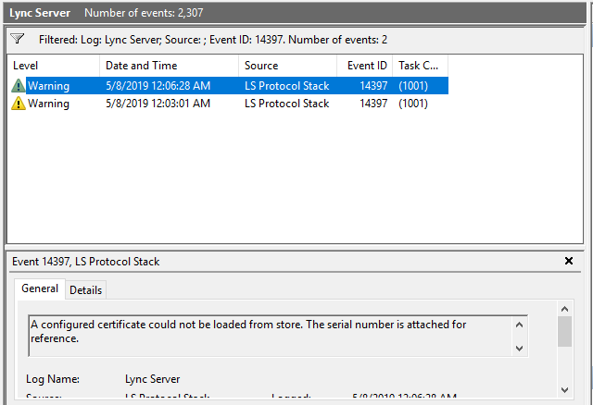

4b) it then gets LS Protocol Stack ERROR (EventID 14623):
A serious problem related to certificates is preventing Skype for Business Server from functioning.
Unable to use a certificate as configured.
Transport:TLS, IP address:0.0.0.0, Port:5061, Error:0xC3E93C0D(SIP_E_STACK_TRANSPORT_CERT_NOT_FOUND).
Ensure that a valid certificate is present in the local computer certificate store. Also ensure that the server has sufficient privileges to access the store.
Cause: The Skype for Business Server failed to initialize with the configured certificate.
Resolution:
Review and correct the certificate configuration, then start the service again.

A serious problem related to certificates is preventing Skype for Business Server from functioning.

Unable to use a certificate as configured.
Transport:TLS, IP address:0.0.0.0, Port:5061, Error:0x800B0109(CERT_E_UNTRUSTEDROOT).
Ensure that a valid certificate is present in the local computer certificate store. Also ensure that the server has sufficient privileges to access the store.

Cause: The Skype for Business Server failed to initialize with the configured certificate.
Resolution:
Review and correct the certificate configuration, then start the service again.

A serious problem related to certificates is preventing Skype for Business Server from functioning.

Unable to use the default outgoing certificate.
Error 0x800B0109(CERT_E_UNTRUSTEDROOT).
The certificate may have been deleted or may be invalid, or permissions are not set correctly.
Ensure that a valid certificate is present in the local computer certificate store. Also ensure that the server has sufficient privileges to access the store.

Cause: The Skype for Business Server failed to initialize with the configured certificate.
Resolution:
Review and correct the certificate configuration, then start the service again.

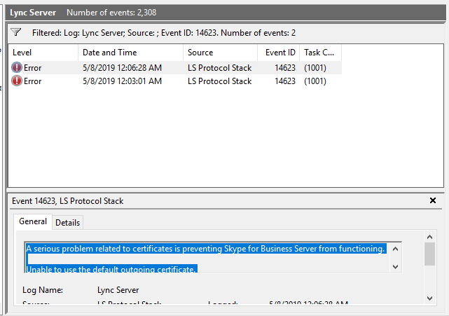

4c) then it goes into shutting down the Front End Service with LS Server ERROR (EventID 12303):
The protocol stack reported a critical error: code 0xC3E93C0D (SIP_E_STACK_TRANSPORT_CERT_NOT_FOUND). The service has to stop.

The protocol stack reported a critical error: code 0x800B0109 (CERT_E_UNTRUSTEDROOT). The service has to stop.

The protocol stack reported a critical error: code 0x800B0109 (Configuration failure prevented the server from starting up). The service has to stop.

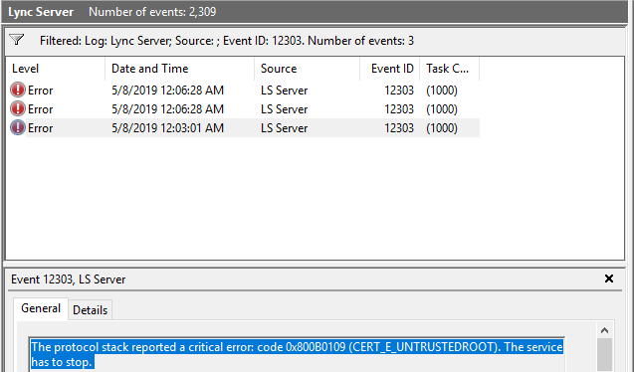

4d) it continues with series of few warnings and erros about not being able to open connection to Storage Service (LS Data Collection EventID 56726), and then after 3 minutes it starts working again and service is brought back up, and no more issues connecting to Certificates store.

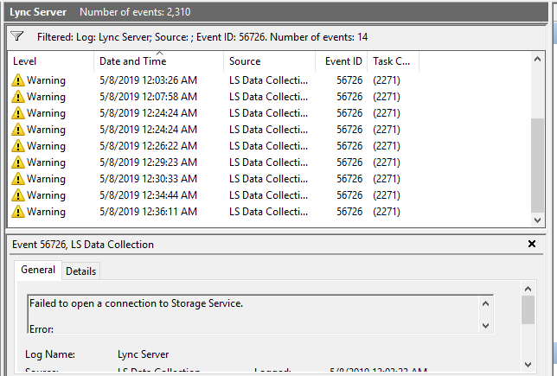

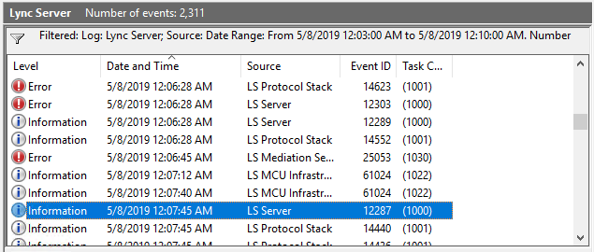

If you think writing all this here in the forum is not right, we could switch to another tool (mail/Skype) so I can describe the issue and we could maybe resolve them)?

