Issue with time format shown in Calendar
- Some calendars show European format while others in AM-PM (although same settings)?
- Browser related? This same calendar shows in Firefox in AM-PM format, while opening it in Google Chrome or MS Edge shows in European format. Other calendars do not have this problem
- Creating a new calendar also shows AM-PM although we use Regional European settings everywhere

Printscreens for Issue 1
Settings of all of our calendars have these:

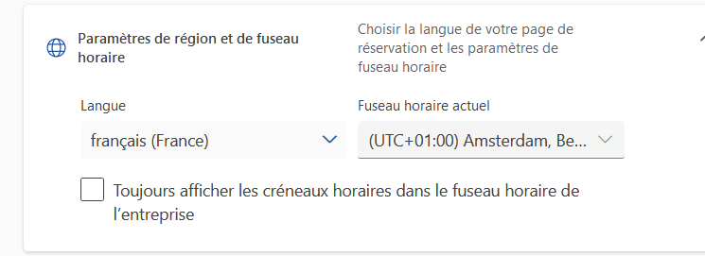

In most calendars this is shown as correct European time (see printscreen below).
Notice in that same printscreen that in the footer text (after Vienna) there is no option to select other time zone.

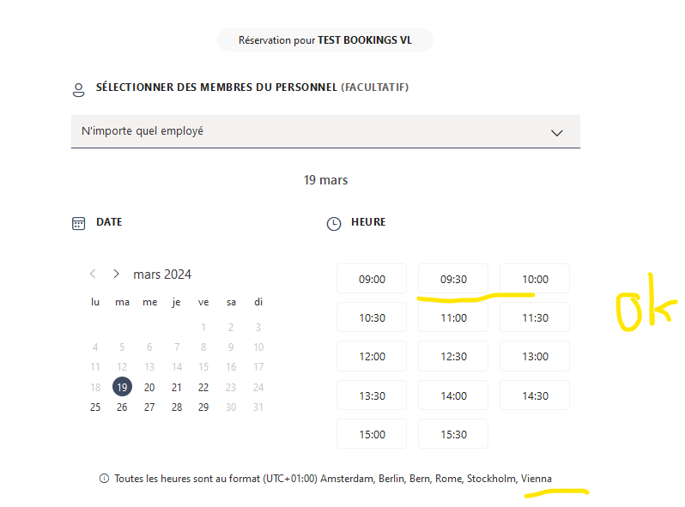

We have other calendars in use that show AM-PM time although Region settings are the same.
Notice in printscreen below that there is a small difference in this footer text where it is possible to select other time zone, while in the other example above this is not possible.

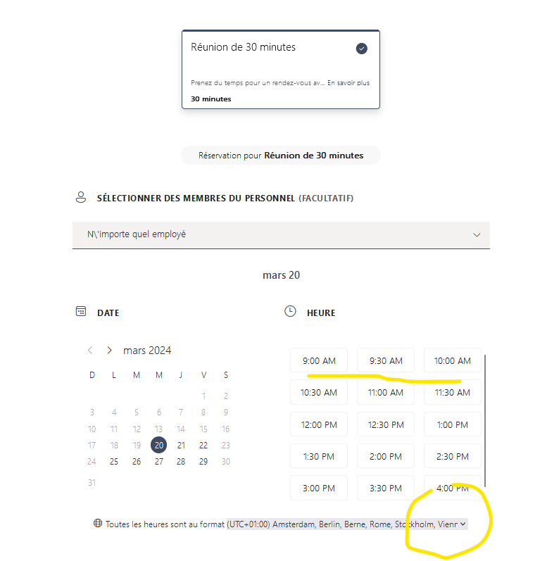

Printscreens for Issue 3
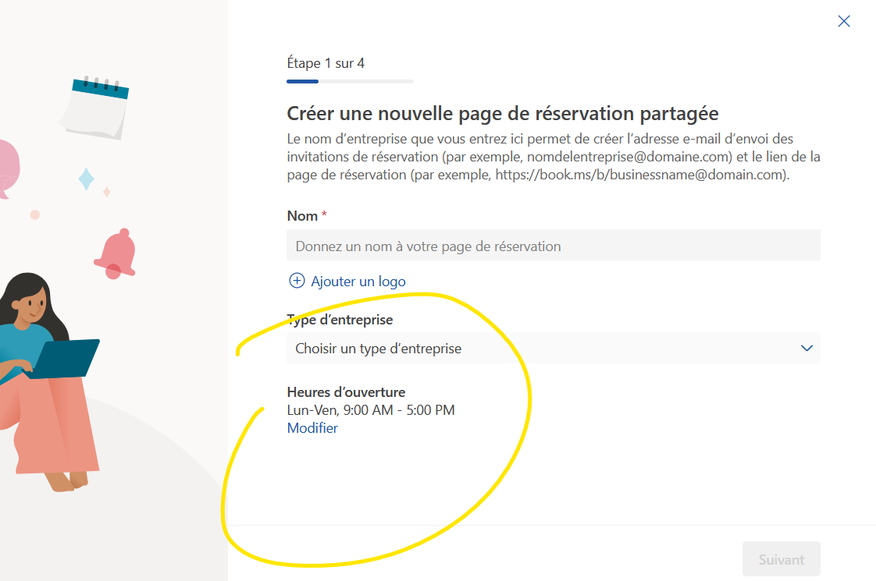
As soon as I hit Modify it changes
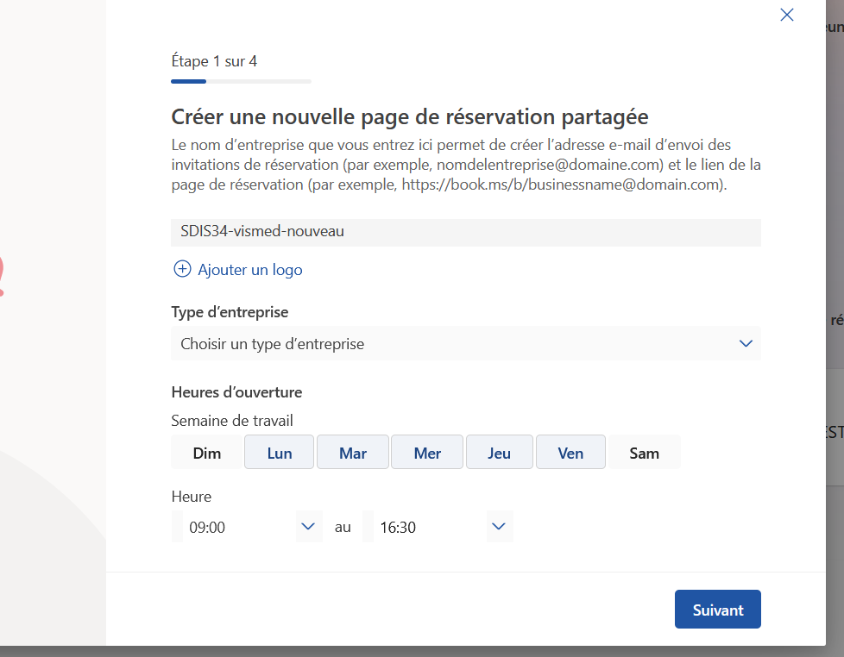

Ditto for 3rd step in creating calendar
