Microsoft Search Administration in M365 Admin Center

Adding Search Administrators

Go to the M365 admin center and ensure that the Preview Mode is turned on:

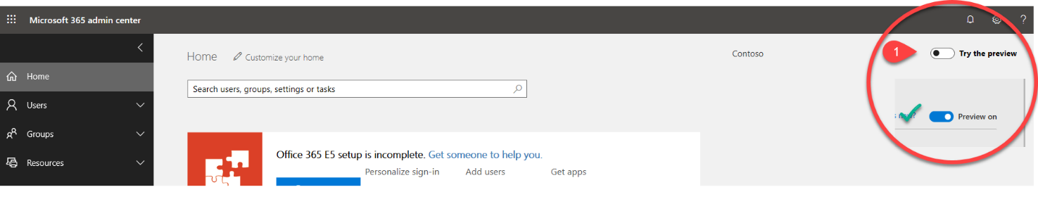
- Expand Settings and note that Microsoft Search is now listed under settings.
- Click on Organization Profile >> Click Edit
- Select either Targeted Release for everyone OR Targeted Release for selected users, and ensure your global admin and search admins/editors are included.
- Click Next to confirm

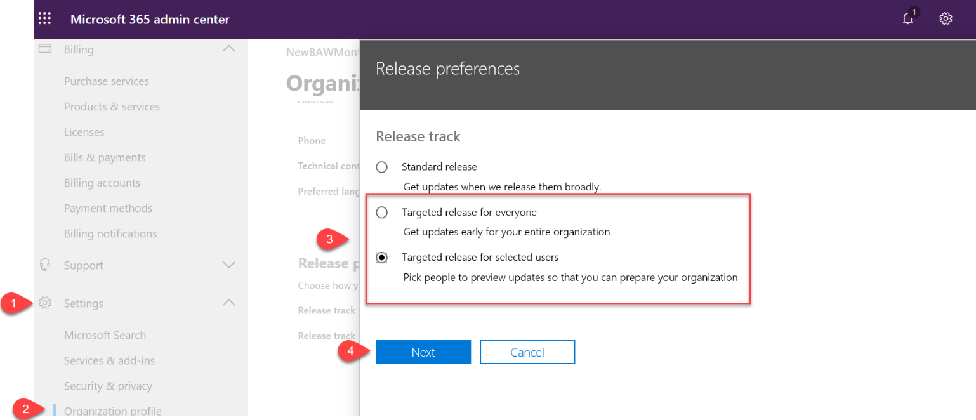

How to assign new search administrator and editor roles to manage Microsoft Search*

Step 1: Ensure the users that you want to make search admins are correctly provisioned with one of the following licenses:

- Office 365 Business Essentials and Business Premium
- Office 365 A1/A3/A5
- Office 365 Education E1/E3
- Office 365 Enterprise E1/E3/E3 developer/E5
- Office 365 F1
- Microsoft 365 Business
- Microsoft 365 A3/A5
- Microsoft 365 F1/E3/E5
To confirm a license:
- Click on Users
- Select Active Users
- In the right column you can see what license they have:

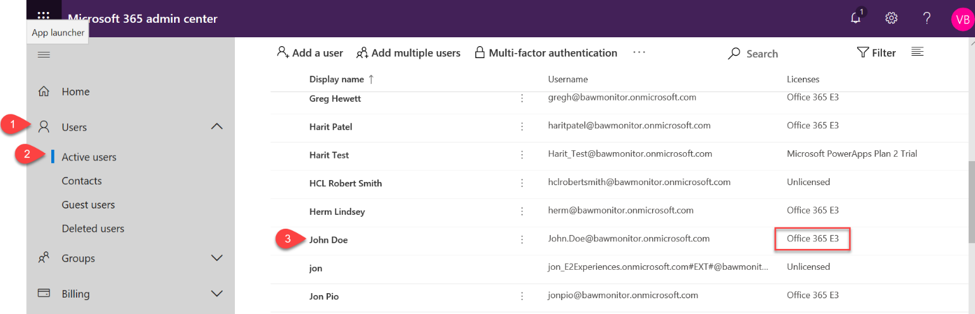

*NOTE: You cannot update your own permissions. To do this another admin account must be used.

Step 2: Enable your selected search admins and/or editors
- Click on Users
- Select Active Users
- Select User
- Click Manage roles
- Select which role(s) to apply

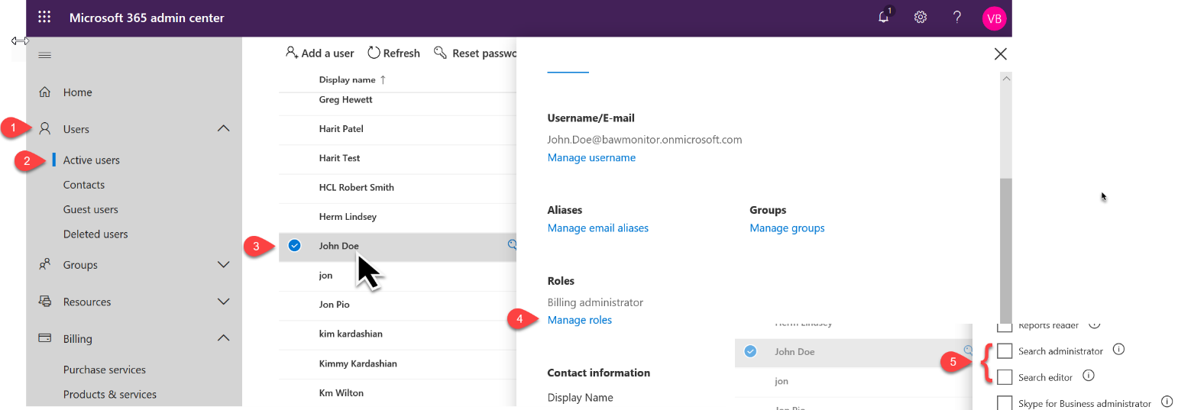

*NOTE: You cannot update your own permissions. To do this another admin account must be used.

After completing the above steps, you will need to wait 24 hours for the system to update. After the update, go to your M365 Admin Center and you will see Microsoft Search as an option under settings.

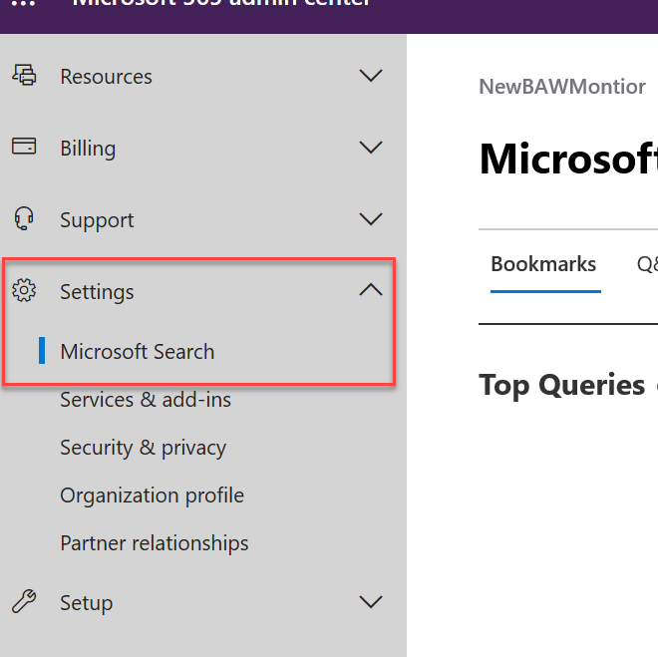

Quick Troubleshooting:

 | Is your user enabled as 1) Global admin, 2) Search admin, or 3) Search editor?
 | Is the user you want to be an admin assigned an appropriate license to use Microsoft Search in Bing?
 | - Office 365 Business Essentials and Business Premium  - Office 365 A1/A3/A5  - Office 365 Education E1/E3  - Office 365 Enterprise E1/E3/E3 developer/E5 | - Office 365 F1  - Microsoft 365 Business  - Microsoft 365 A3/A5  - Microsoft 365 F1/E3/E5
Is Preview mode enabled? (https://admin.microsoft.com/AdminPortal/Home#/homepage)
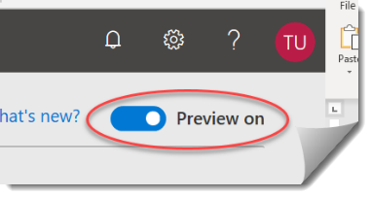
 | Have you waited 24 hours for the system to update after enabling your new admins?

