VM in Pricing Calculator (in two different browsers) and found the same issue. (After Login)

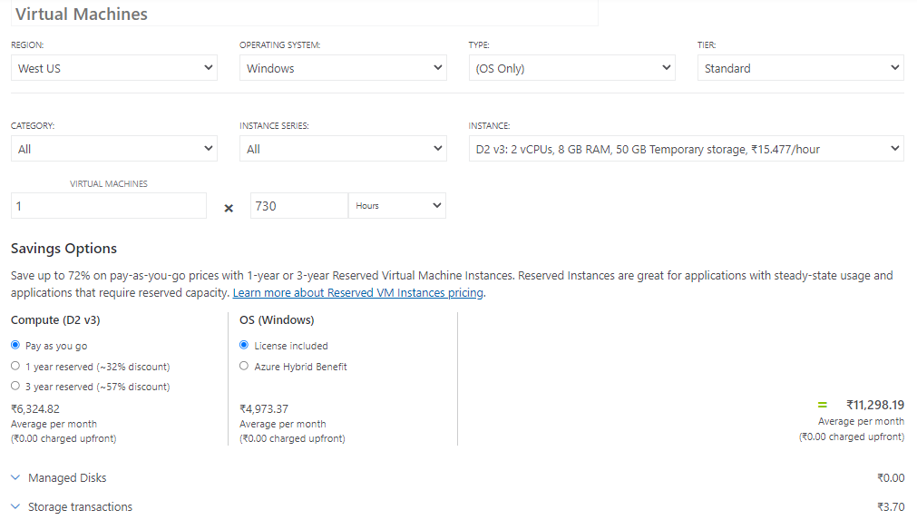

VM in Pricing Calculator (in two different browsers) and found the same issue. (Before Login)

